Session 21

|  |
| --- |
| **Objectives**  The goals of this session |
| 1. Finish random tree activity (focus activity 1) 2. Recap loops |

|  |
| --- |
| **Method Focuses**  New methods or functions that you will learn during this session |
| No new methods |
| **Property Focuses**  Properties (variables) of classes you will learn during this session |
| No new properties |
| **Documentation Links** |
| For Loops <https://www.w3schools.com/cs/cs_for_loop.asp>  While Loops  <https://www.w3schools.com/cs/cs_while_loop.asp> |

## Focus Activity 1

**Goal**

Create a platform and have trees randomly spawn on that platform.

This will require knowledge of:

* Spawning prefabs
* Making random numbers
* Loops
* Changing the position of an object
* Creating materials

The outcome should look like this:

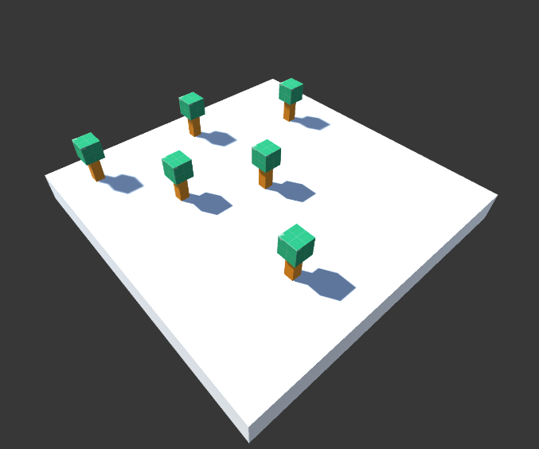

|  |  |
| --- | --- |
| **Session Information**  You can ignore this | |
| **Planned Information** | |
| Session Time Session Date | 5:00PM – 6:00PM AWST 11 February 2021 |
| **Real Information** | |
| Session Time Session Date |  |
| Github Name | Session21Examples |
| Session Length |  |
| Activities Completed | |  |  | | --- | --- | | □ | Finish Focus Activity 1 | |
| Signature | ____________________________________________  *By signing this you confirm that the session has occurred and the subjects that have been taught have been allocated on this document.* |